Meeting Notice and Agenda
Town Board of Trustees
Regular Meeting
July 18, 2023 – 6:30 pm
Mounds Community Building
15 W 14th Street, Mounds OK 74047

1. Call to Order Time: _____________

2. Roll Call

Long _____ Pounds _____ McNabb _____ Jackson _____ Culbert _____

3. Consent Agenda (A-K)
All matters listed under “Consent” are considered by the Town Board to be routine and will be enacted by one motion. Any Trustee, however, can remove an item from the Consent Agenda by request.

A. Approval of the Minutes for the June 6, 2023, regular meeting.
B. Approval of the Library report
C. Approval of the Police report
D. Approval of the Fire report
E. Approval of the Financial report
F. Approval of the Budget report
G. Approval of the Court report
H. Approval of Purchase Orders for Streets & Alleys and Parks Departments
I. Building Inspector Report
J. Approval of the Purchase Orders for General Government, Streets & Alleys, and Court Fund
K. Approval of bad debt write-off: Account 462 – 124 E. 5th PL $77.10 sewer. Acct. 38 – 9 W 8th St. $9.50 sewer. Acct. 456 – 110 E. 5th Pl $9.61 lead adjustment – sewer.

Motion: _________________________ Second : _________________________
Long _____ Pounds _____ McNabb _____ Jackson _____ Culbert _____
4. Fireworks
Discuss, consider, and take possible action on Fireworks.
Motion: _________________________ Second : _________________________
Long _____ Pounds _____ McNabb _____ Jackson _____ Culbert _____
5. Easter
Discuss, consider, and take possible action on Easter.
Motion: _________________________ Second : _________________________
Long _____ Pounds _____ McNabb _____ Jackson _____ Culbert _____
6. New Officers (Fire Department)
Discuss, consider, and take possible action on swearing in new Officers for the Fire Department.
Motion: _________________________ Second : _________________________
Long _____ Pounds _____ McNabb _____ Jackson _____ Culbert _____
7. Fire Department Surplus
Discuss, consider, and take possible action on Fire Department Surplus items.
Motion: _________________________ Second : _________________________
Long _____ Pounds _____ McNabb _____ Jackson _____ Culbert _____
8. Gazebo
Discuss, consider, and take possible action on accepting gazebo donation from Native Fusion.

Motion: _________________________ Second : _________________________
Long _____ Pounds _____ McNabb _____ Jackson _____ Culbert _____
9. Executive Session
The Trustees will consider retiring into Executive Session for the purpose of discussion for item A. related to the employment, hiring, appointment, promotion, demotion of individual salaried (Building Inspector) officer or employee in accordance with O.S. Title 25, Section 307(B)(1).
Time: ____
Motion _____________________ Second _______________________
- Long _____ Pounds _____ McNabb _____ Jackson _____ Culbert _____
- Trustees will consider and take any action deemed appropriate to
Motion _____________________ Second _______________________
Roll call: Long _____ Pounds _____ McNabb _____ Jackson _____ Culbert _____

10. Adjournment ____

This Agenda was filed in the office of the Town Clerk and posted at 6 PM on July 17, 2023, at the Mounds Municipal Building located at 1319 Commercial Avenue, Mounds, OK 74047 and the Mounds Community Building located at 15 W 14th Street in Mounds, OK 74047, by Town Clerk Kristin Haddock.

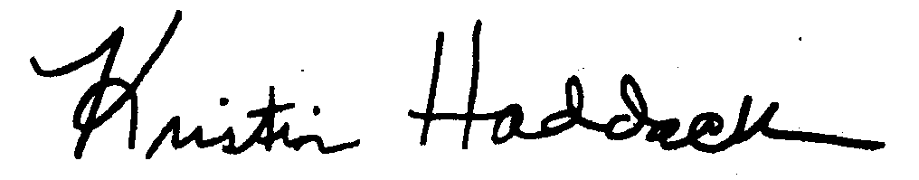
Kristin Haddock, Town Clerk

